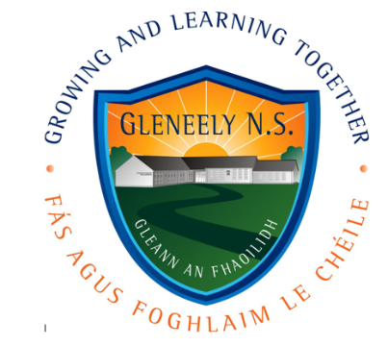**Scoil Náisiúnta Gleann an Fhaoilidh,**

**Crossroads, Killygordon,**

**Co. Donegal.**

**Uimhir Rolla 18172F.**

[**www.gleneely.com**](http://www.gleneely.com) **074 9149395 Email:** [**principal@gleneely.com**](mailto:principal@gleneely.com)

**School Enrolment Form**

**NB: Please ensure that following accompany this Enrolment form**

|  |  |
| --- | --- |
| **A copy of the child’s BIRTH CERTIFICATE** | 🞎 |
| **A copy of the BAPTISM CERTIFICATE**  **(if applicable)** | 🞎 |

**Child Details**

|  |  |
| --- | --- |
| **Name of child**  **(on birth cert):** |  |
| **Date of Birth:** |  |
| **Address:** |  |
| **PPS Number:** |  |
| **Gender:** | Male [ ] Female [ ] |
| **Country of Birth:** |  |
| **Nationality:** |  |
| **Religion:** |  |
| **Mother’s maiden name:** |  |
| **Is one of the pupil’s mother tongue English or Irish** | Yes [ ] No [ ] |
| **Doctor’s name** |  |
| **Doctor’s address & Tel No.** |  |
| **Any allergies / Medications:** |  |
| **Please indicate any special health problems that the school should be aware of:** |  |

**Guardian Details**

|  |  |  |  |
| --- | --- | --- | --- |
| **Legal Guardian 1** | | **Legal Guardian 2** | |
| **Name:** |  | **Name:** |  |
| **Occupation:** |  | **Occupation:** |  |
| **Mobile No.** |  | **Mobile No.** |  |
| **Work No.** |  | **Work No.** |  |
| **Email:** |  | **Email:** |  |

**Additional Contacts Details in case of emergency**

|  |  |  |
| --- | --- | --- |
| **Name** | **Number** | **Relationship to child** |
|  |  |  |
|  |  |  |
|  |  |  |

**Please make the school aware as early as possible of any family situation such as bereavement, or separation that could impact on your child, so that we can be as supportive as possible.**

**Please tick to give consent to the following as appropriate:**

|  |  |
| --- | --- |
| Screening tests are carried out in the school on all children from infants to 6th class. Do you give permission for your child complete these tests? |  |
| During your child’s time in Gleneely NS it may be necessary to carry out diagnostic testing on an individual basis, in order to help your child in their educational development. Do you give permission for any necessary diagnostic testing to be carried out on your child? |  |
| Do you give permission for your child to receive additional help from Special Educational support in school? (Parents will be notified should it be recommended) |  |
| Do you give permission for your child to be taken to hospital in case of emergency, if you cannot be contacted? |  |
| Do you give permission for Inclusion of your child’s photographs on our school website / Private School Facebook Group? |  |
| Do you give permission for inclusion of your child’s photographs in a local/national newspaper? |  |
| Do you give permission for some of this information may be shared with other agencies (e.g H.S.E, Department of Education and Pupil Online Database) who require it? |  |
| Do you give permission for your child’s uniform to be changed by adult members of staff in case of illness or toilet accident? |  |
| We have received and read a copy of the “Code of discipline”  and “Anti-bullying policy”. |  |

**Signatures**

|  |  |  |
| --- | --- | --- |
|  | **Name** | **Date** |
| **Legal Guardian 1** |  |  |
| **Legal Guardian 2** |  |  |